Process flow – Corrections
- In Sandhiya’s panel,
  - probability section not required, please remove it.
  - Source and business segment are seperate i.e, Source: Indiamart means we have to select the Business Segment and based on the business segment the HOD may allotted automatically.
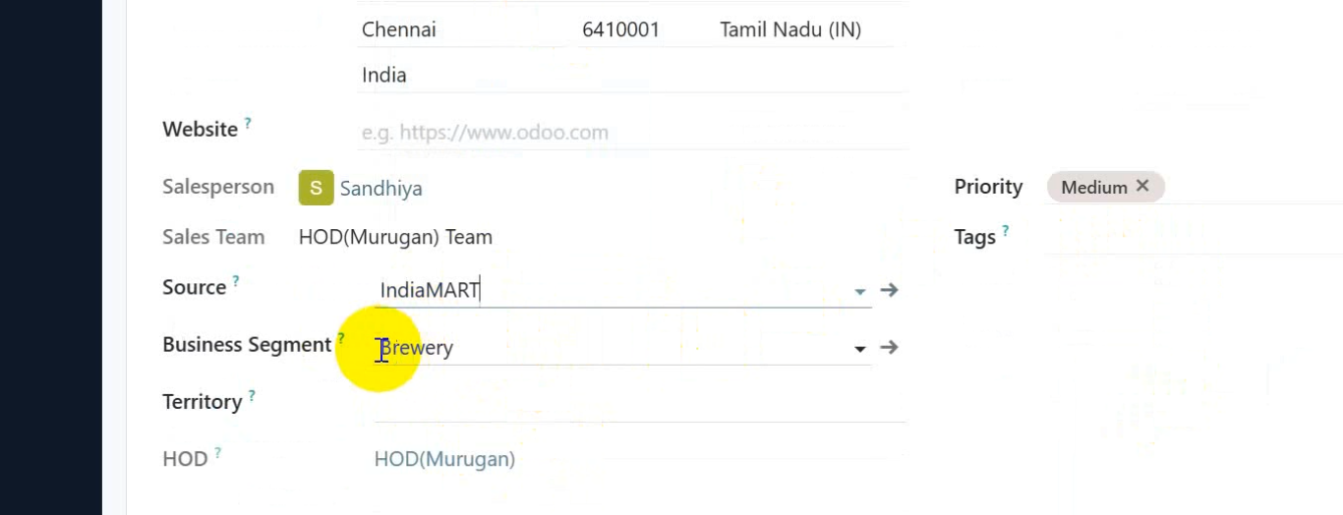
  - Tag must be changed to Product and the scroll down options should be Bottle Water, Brewery, PET Machine, RFC , Bottling Plant, etc
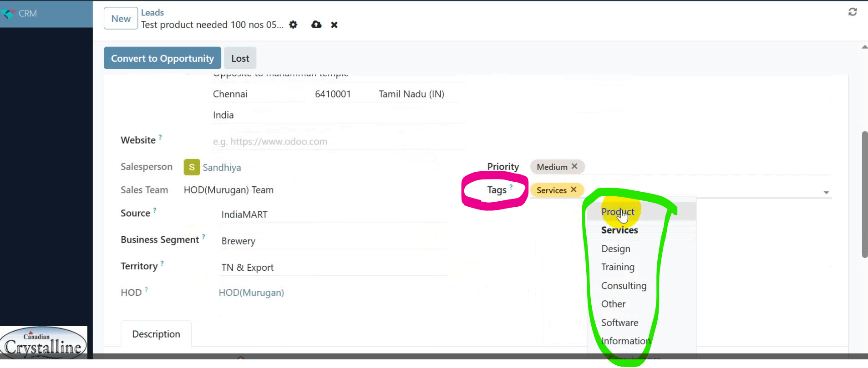
  - Sandhiya user must not have permission to change the enquiry or lead to LOST (Her work is to enter the data and to assign that’s it)
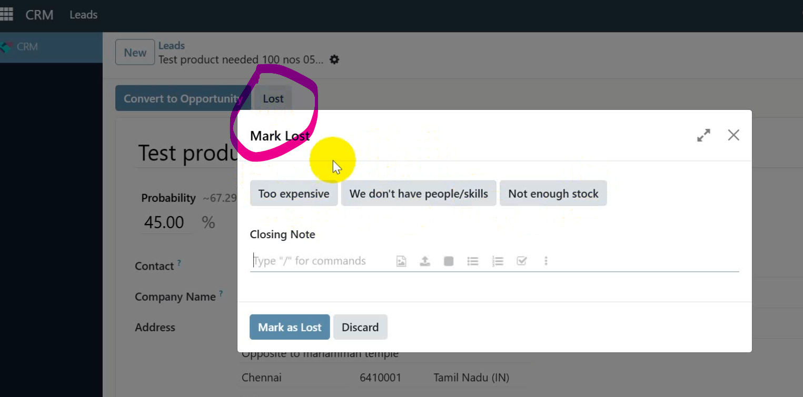

- In HOD’s panel,
  - Whenever the HOD login to the panel, it should land in the HOD dashboard (new one) only
